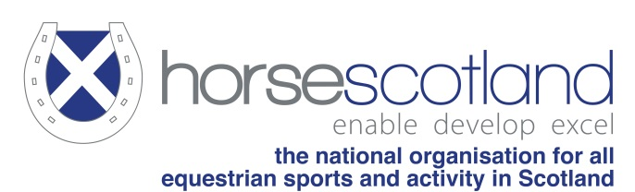
Board Vacancy
horsescotland is the national organisation for all equestrian sports and activity in Scotland.
Our shared vision is:
To enable those in our sport and sector,
by supporting their development,
to excel in what they do best…

The key outcomes for Scottish equestrianism are to:

- increase the overall levels of participation and equestrian activity in Scotland
- enable Scottish riders, drivers, vaulters and equines to excel on the world stage
- support horsescotland Member Bodies to flourish by working collaboratively

The Opportunity

As one of our Board Directors you will gain expertise, supporting and advising a dynamic Board and will help to shape the future of Scottish equestrianism. This is a great opportunity for someone with a passion for equestrian sport and presents great potential for the development of new/existing skills and meeting a new network of people. In this role you can make a genuine difference to equestrian sport at the highest level in Scotland.

horsescotland is looking to appoint an experienced and enthusiastic individual to oversee the governance of horsescotland and the delivery of the organisation’s Strategic Plan. The Board Director roles are key to the fundamental progression of horsescotland and you will be an integral member of the Board, assisting with driving the strategic direction of the organisation.

To support and drive our ambition to develop equestrianism performance, development and participation activity in Scotland, the Board is looking to appoint to the following role:

Board Director – Performance

horsescotland is looking to appoint an experienced and enthusiastic individual to oversee the organisation’s Performance Programmes.

Main Duties:

- To promote the success of Scottish performance and development athletes in equestrianism.
- Provide regular updates to the Board on matters relating to the above horsescotland programmes
- Develop and monitor budgets relating to the above horsescotland programmes
- Work in conjunction with, and provide support to, the horsescotland Performance Manager in the delivery of their role. In particular, being the key link for communication and support from the Board.
- Contribute to the overall strategic direction of horsescotland
- Contribute to strong and balanced Board governance

Skills/Experience/Attributes:

- Previous experience and knowledge of performance pathways and programmes
- Be able to demonstrate a good understanding of the competitive sport horse industry
- Experience of strategic planning and programme design and delivery
- Commitment to horsescotland values, vision, objectives and code of conduct
- Good listening and communication skills
- Ability to maintain, strong, constructive working relationships with other Board Directors, staff, volunteers and partner organisations
- An objective approach to decision making
- Enthusiastic and confident to act as an Ambassador for horsecotland
- Ability to commit time and effort to attend formal Board meetings and other ad hoc meetings

Time Commitment:
The Board meets 6-10 times per year at various locations across central Scotland and increasingly online. In addition to formal Board meetings you will be expected to use your skill set to support the horsescotland team when required.

Remuneration:
The post is on a voluntary basis and is non-remunerated.

Terms and Conditions:
A Director is initially appointed by the horsescotland Board, with this appointment ratified by the members at the subsequent Annual General Meeting. The term of a Director will be as set out per the horsescotland Articles of Association

Recruitment Process:
To apply for the position please e-mail a short CV with a covering letter outlining why you feel you are the right person for the role. This will be followed up by a short meeting with the horsescotland Nominations Committee.

Should you wish an informal discussion on this role please contact chair@horsescotland.org.

To apply for the role we ask that you follow either the independent or Member organisation flowchart below to apply to via e-mail your CV and letter marked private and confidential to fiona@horsescotland.org. By 31 May 2020.

If your application is support by a member body please note that we already have Member body Directors for British Horse Society, Scottish Endurance Riding Club, World Horse Welfare and Riding Clubs so these Member bodies are unable to support applications.

Organisational Director

* If a position was advertised at another period during the year, the process would be as above and the members would be invited to attend and vote at an EGM
Independent Director

