Sign in
- Go to https://horsescotland.beezer.com/sign-in

- If this is the first time you have accessed your account, please click ‘Forgotten Password?’, fill in your email address and change your password.

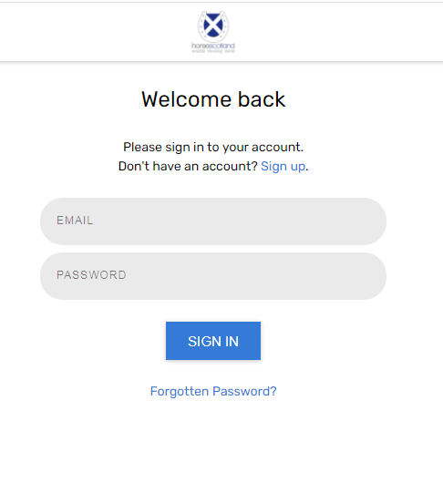

Personal user profile

- Go to your user profile which is located in the top right corner menu of the app (select the ⋮ menu at the top right corner) and click ‘Profile’
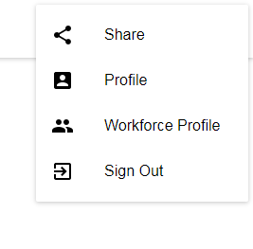
- You can also complete your profile by clicking on “Complete your personal profile” which is located on the workforce profile page.
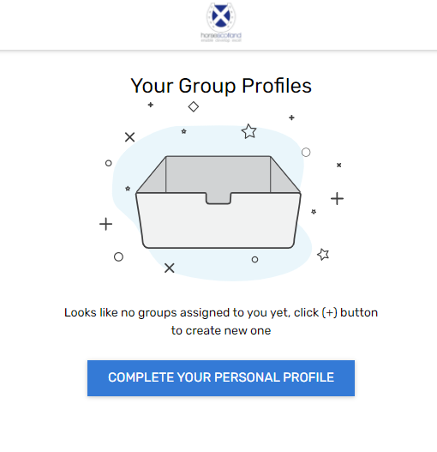
Complete the user profile fields and click ‘Save’ at the end:
- Personal info
- Address info
- Social info

- Go to your Workforce Profile which is located in the top right corner menu of the app (select the ⋮ menu at the top right corner) and click ‘Workforce Profile’

- Select a group that you are a part of (you can be part of multiple groups). Please note you may have already been added to a Group by the horsescotland admin.
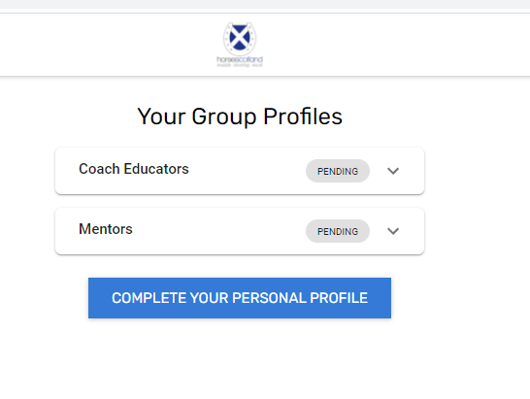
- Click on the Group(s) that are Pending. Check that the information in the fields is correct.
- If no groups are showing, click on the green + to add a group

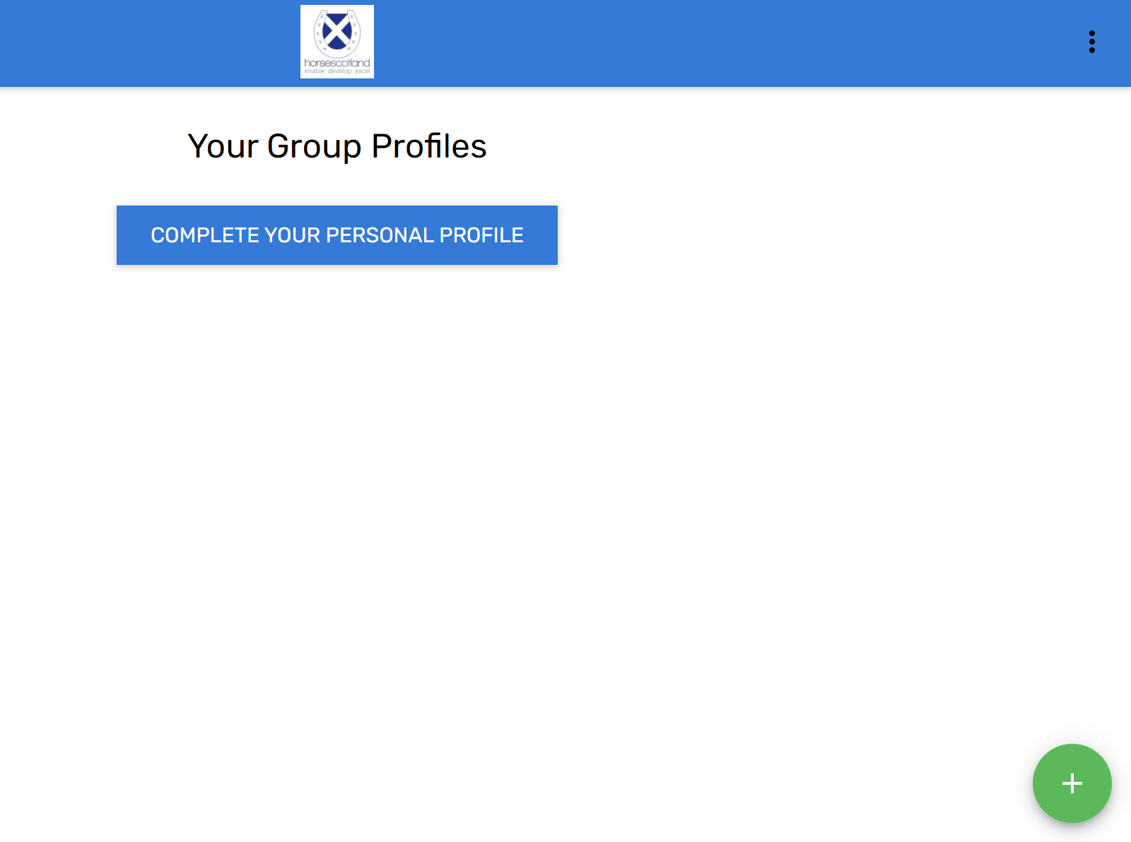

- Don’t forget to complete the code of conduct field - you can download a copy of the horsescotland Code of Conduct from the Code of Conduct box by clicking ‘SAMPLE’ (see above).
NB All workforce members must agree to abide by the horsescotland code of conduct

- Please ensure you answer ‘Yes’ or ‘No’ in the final field which states ‘I hold an assistant coach qualification and will therefore only coach under fully qualified supervision’ All Level 1 (Assistant) coaches must confirm that they are only coaching under supervision to be part of our coaches register.

- A member of horsescotland will review your application to the specific workforce group. Once they have approved it you will receive an email to confirm that it has been approved and your profile will be displayed as part of the Group under ‘Find a Coach’ in the app: https://horsescotland.beezer.com/find-a-coach

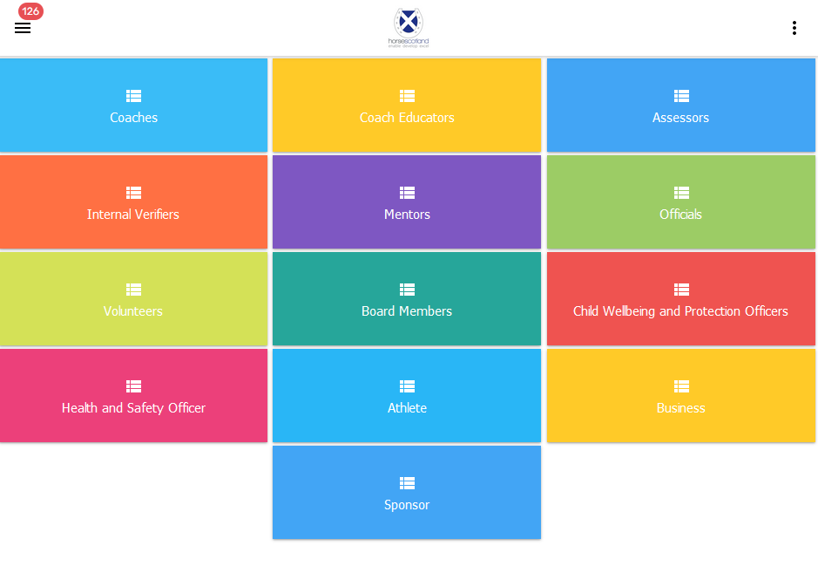

- App users will be able to find your profile in the Find a Coach page of the app (as seen above). They will also be able to Contact you by completing a form which will be sent to your email address.

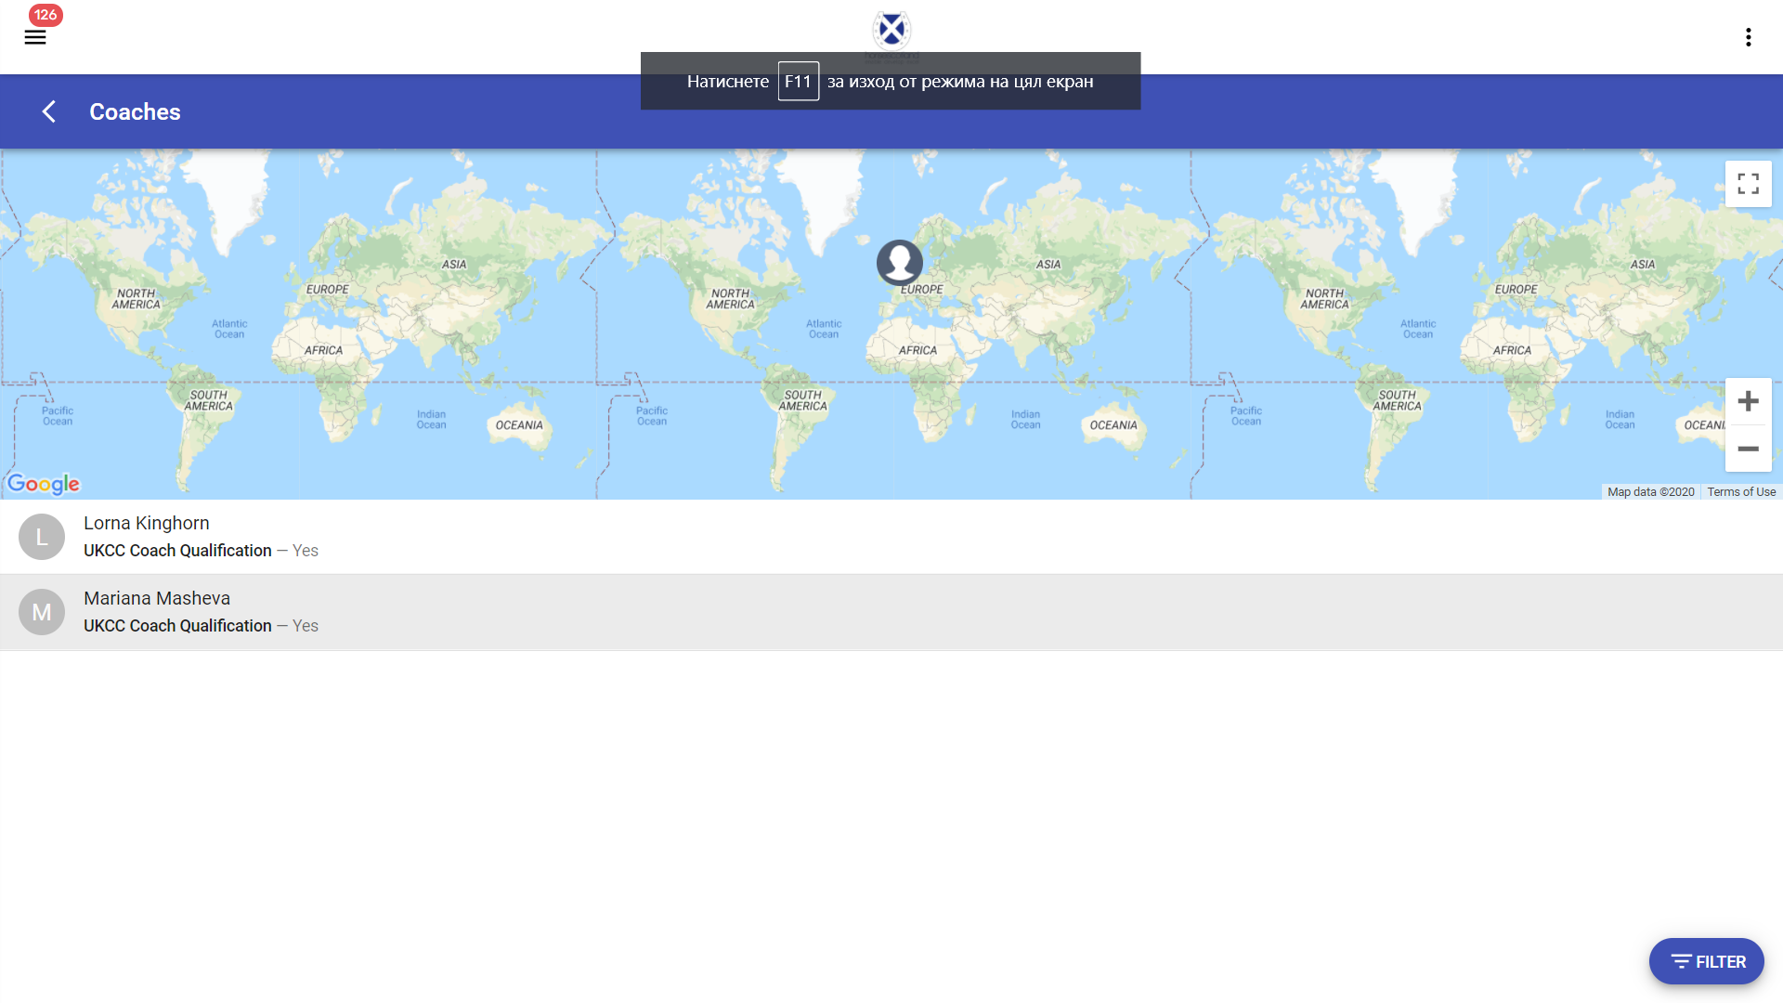

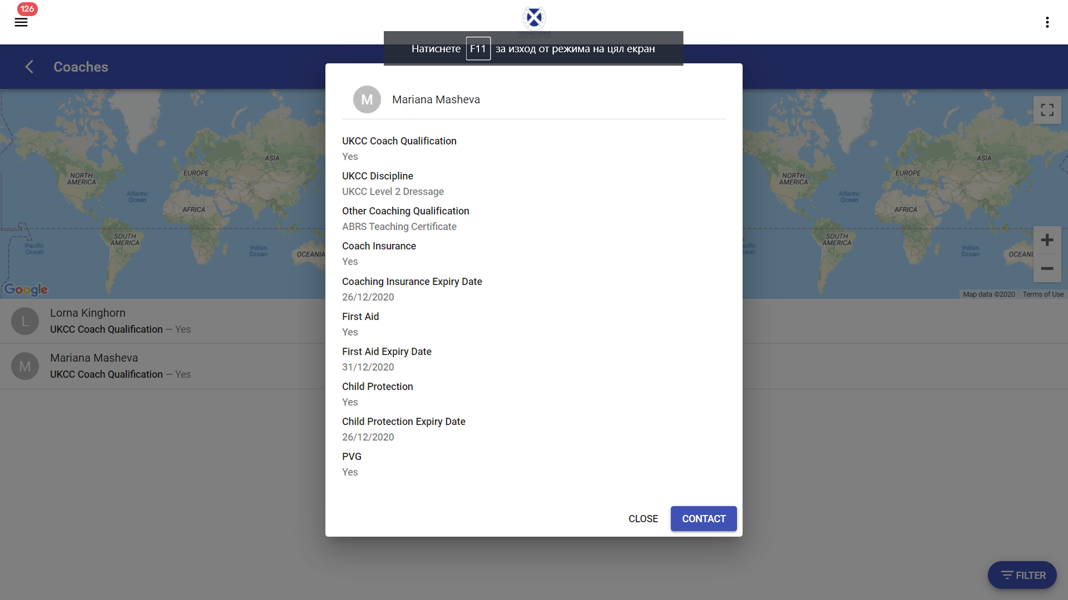

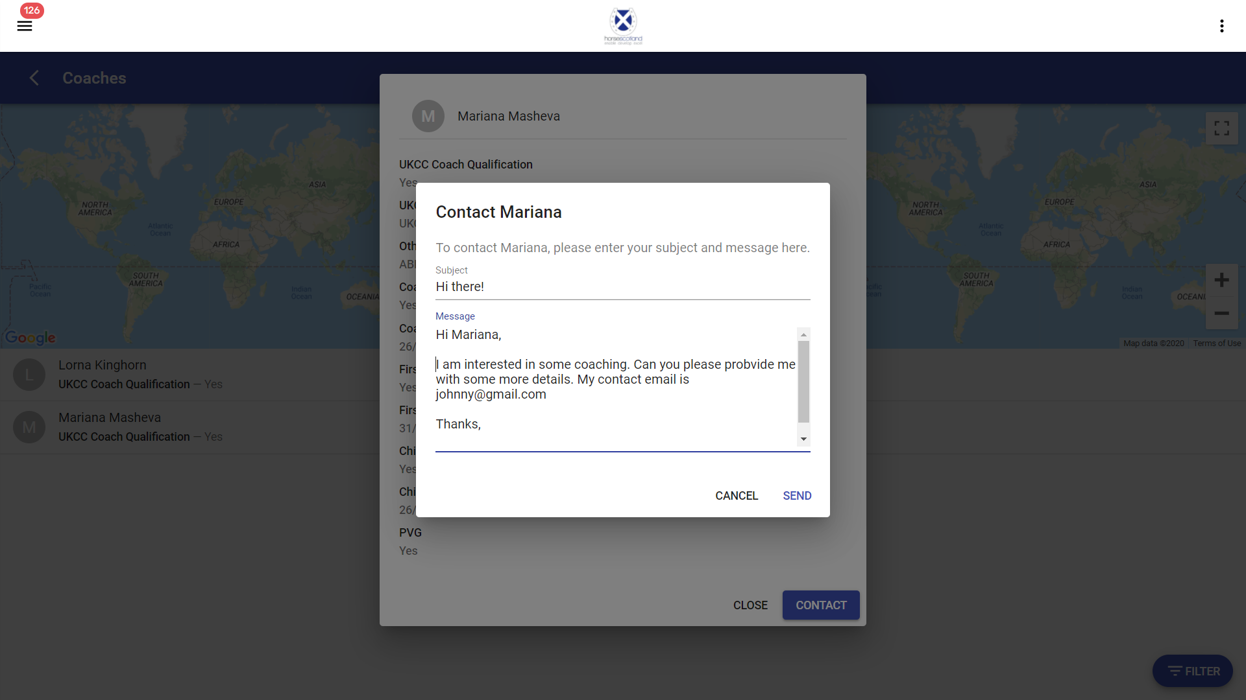

Edit a Workforce Group profile

- You can always go back to the Workforce profile and edit any of the fields including First aid expiry date and other important information that might need to be updated over time.
- Every time when you submit new information in your Workforce Group profile, it will be sent for review by the horsescotland app admin, and your Group status will be shown as Pending.
- You will receive an email confirmation after the horsescotland app admin has approved your changes to the workforce group profile and the status will be changed to Active.

Using the app as an end user
As a Workforce member you will also be able to use the app as a regular end user. You will be able to access all pages in the app: https://horsescotland.beezer.com/

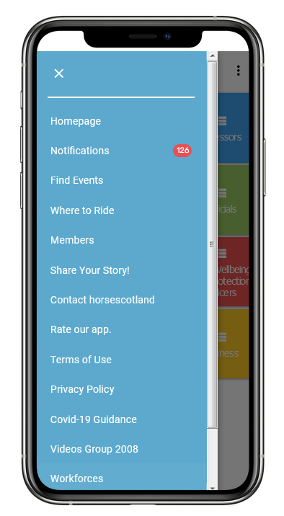

Install the horsescotland app on your device

- To install the app on your device, please visit this link https://horsescotland.beezer.com/ from your mobile device
- You will be asked to install the app by clicking the banner popup at the bottom of the screen.

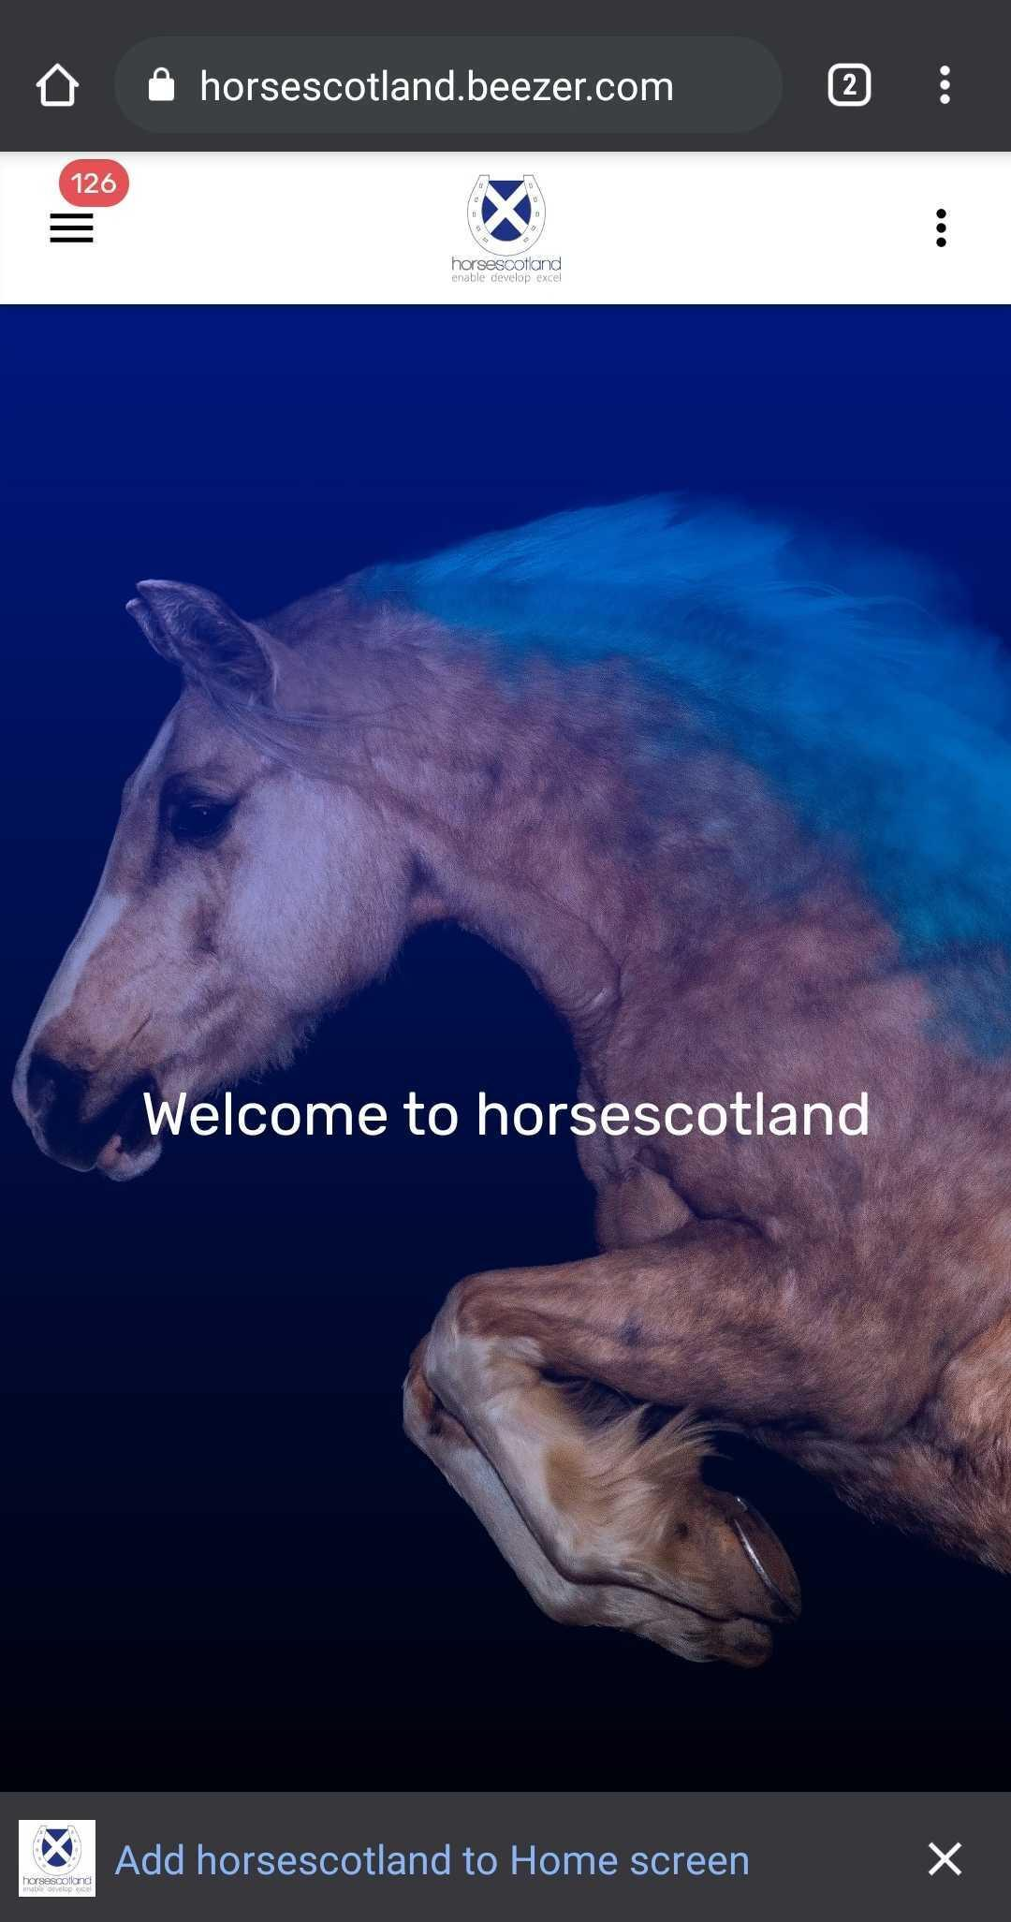
- After clicking the 'Add to Home screen' link you then press add. (If you have dismissed the prompt you can add manually by choosing Add to Home Screen from the Settings menu of the browser).
- 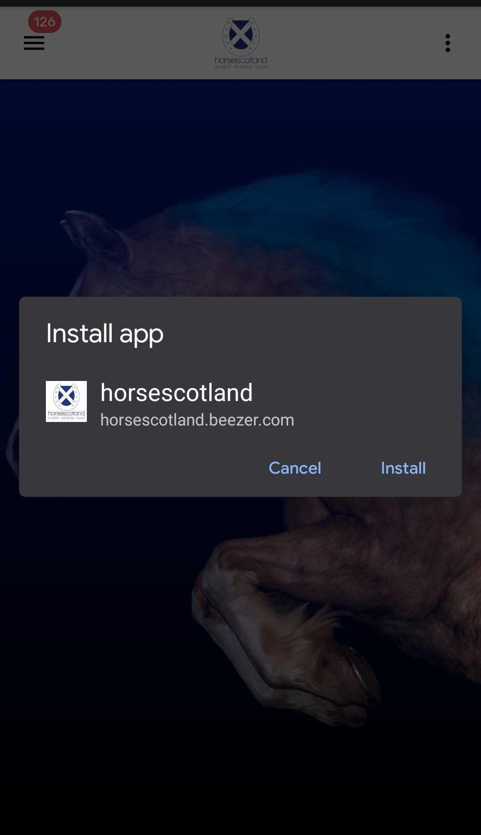

App is installed to the Home Screen and a dot will appear showing new notifications have been sent.

