Child Protection Workshops
Child Wellbeing & Protection in Sport
Thursday 20th February 2020
The Bridge, Dumfries
6.00pm – 9.00pm
£25.00

Child Wellbeing & Protection in Sport
Wednesday 4th March 2020
Annan Town Hall
6.00pm – 9.00pm
£25.00
For more information please contact:
Susan Bryson
Tel: 0303 333 3000
Internal: 60285
Drop Point: 258
email: Susan.Bryson@dumgal.gov.uk

Website: http://www.dumgal.gov.uk

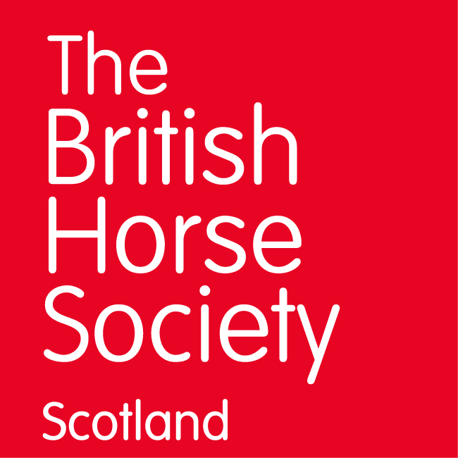

Thursday 13 February 2020
Cabin Equestrian Centre, Ordyfauld, Inverurie AB51 0LL
6-9pm

Saturday 22 February 2020
The Ormidale Pavilion, Shore Road, Brodick, Isle of Arran, KA27 8DL
11.30am to 2.30pm
The CWPS eLearning module 1 MUST be completed by learners before attending module 2.Your certificate of attendance will not be issued until both modules are undertaken.
FREE for BHS Accredited Professional Coaches / £20 for all others
If you are an APC, please email tricia.halley@bhs.org
Non APCs book your ticket online

