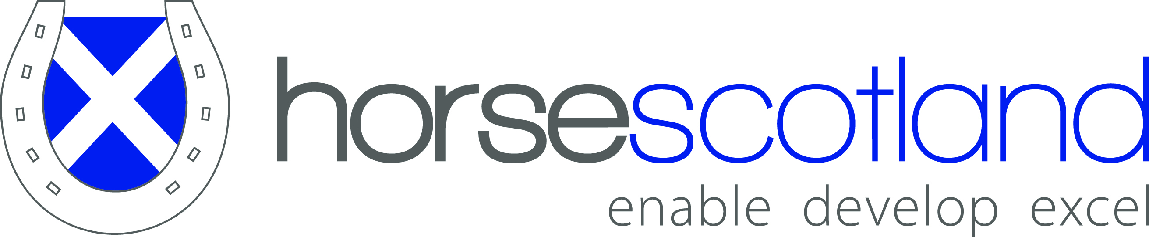

Full Membership
Application Form

Organisation Details:
Club Name:
Address:
Postcode:
Telephone Number:
Mobile Number:
E-mail address:
Web address:
Social Media details:
e.g. Facebook/ Twitter

Primary Contact:
Name:
Organisation Designation:
(e.g. Chair/ Member)
Address:
Postcode:
Telephone Number:
Mobile Number:
E-mail address:

Secondary Contact:
Name:
Organisation Designation:
(e.g. Chair/ Member)
Address:
Postcode:
Telephone Number:
Mobile Number:
E-mail address:

If the Primary and Secondary contact are not your Chair or Treasure can you please provide their details too:

Chair:
Name:
Address:
Postcode:
Telephone Number:
Mobile Number:
E-mail address:

Treasurer:
Name:
Address:
Postcode:
Telephone Number:
Mobile Number:
E-mail address:

What is the main aim of your organisation?

________________________________________________________________

________________________________________________________________

________________________________________________________________

What are your membership figures?

Female Members _____ Male Members _____

Junior Members (U18s) _____ Adult Members _____

Total Membership _____

Has your organisation ever applied for an: - Awards for All Grant or Sportsmatch grant?

Yes / No*

*Please delete/ circle as appropriate

Child Protection Officer:
Name:
Address:
Postcode:
Telephone Number:
Mobile Number:
E-mail address:
Please submit a copy of appropriate certificates

Health & Safety Officer:
Name:
Address:
Postcode:
Telephone Number:
Mobile Number:
E-mail address:
Please submit a copy of appropriate certificates

Do you have children or vulnerable adults within your groups?
Yes / No*

Do all the groups within your organisation have a Child Protection Officer & Policy?
Yes / No*
*Please delete/ circle as appropriate

In addition to the previous information, we would be grateful for the following information. If you are unclear about the meaning of some of these details, please pass to the person in your organisation who usually looks after organisational and legal matters.

Thank you for your help.

- Formal name of your organisation in Scotland

________________________________________________________________

- What is the legal status of your organisation?

________________________________________________________________

E.g. Company limited by guarantee
Company limited by shares
Unincorporated association
Branch of UK body which is one of the above.

- Do you have a constitution covering your Scottish organisation? Yes/No *
If so please provide a copy.

- Do you produce audited or certified accounts for your Scottish organisation and two signatories on the cheque book? Yes/No *

- Does your Scottish organisation hold an AGM every year? Yes/No *

- How many AGMs has your Scottish organisation held? _______

- Do you approve your accounts at your AGM each year? Yes/No *

- Do you agree to sign up to all horsescotland’s Plans and Policies? Yes/No *

* Please delete/ circle as appropriate

Please sign to confirm all the information you have provided is accurate:

A full copy of horsescotland’s Memorandum of Articles and Understanding can be found on horsescotland’s website at www.horsescotland.org

Membership Costs

Full Membership
No. of Registered Members | Fee
5,000 and over | £575
2,000 to 4,999 | £475
1,000 to 1,999 | £375
100 to 999 | £309
0 to 99 | £103

Member Benefits
- Access to sportscotland and Lottery Funding, and other public funding sources
- Guidance to affiliated organisations on how best to apply for Lottery funding from sportscotland
- Direct Interface with Scottish Government
- Access to a range of policies, e.g. equity, child protection, health and safety
- Access to the Protection of Vulnerable Groups Scheme Registration
- Advice and support helpline
- Programme support, e.g. Rider Development, Coach Development, Volunteer Development
- Promotion of Member Body activity and events on horsescotland website
- Access to UK Coaching Certificate Resources and Candidate Funding
- Access to horsescotland investment support

Further information on all the above mentioned policies and procedures can be found at www.horsescotland.org and you are able to adopt all relevant horsescotland policies

For any further help please contact info@horsescotland.org or phone 07834 558916

Please send completed forms, cheque (made payable to horsescotland) and supporting documents (a copy of your Insurance, Child Protection and Health & Safety Officers Certificates and three years accounts if applicable)

horsescotland
P.O. Box 8523
Prestwick
KA9 9AX

horsescotland is a Company Limited by Guarantee, Company Number 277875

